Docker and Kubernetes are essential tools in modern software development. While Docker focuses on creating and managing containers, Kubernetes is an orchestration platform that manages these containers at scale. Here’s a detailed explanation of containers (Docker) and pods (Kubernetes):

1. Containers (Docker)

1.1 What is a Container?
A container is a lightweight, standalone, and executable software package that includes:
- The application.
- All dependencies (libraries, binaries, and configuration files).
Containers are isolated from each other and the host system, sharing the same kernel.

1.2 Features of Containers
- Lightweight: Containers share the host OS kernel, unlike virtual machines.
- Portable: Run on any system that supports containerization (e.g., Docker, containerd).
- Fast Start-up: Compared to virtual machines, containers are much quicker to start.

1.3 Docker's Role
Docker is the most popular containerization platform. It provides:
- Tools for building, running, and managing containers.
- A registry (Docker Hub) for storing and distributing container images.

Example of a Dockerfile:
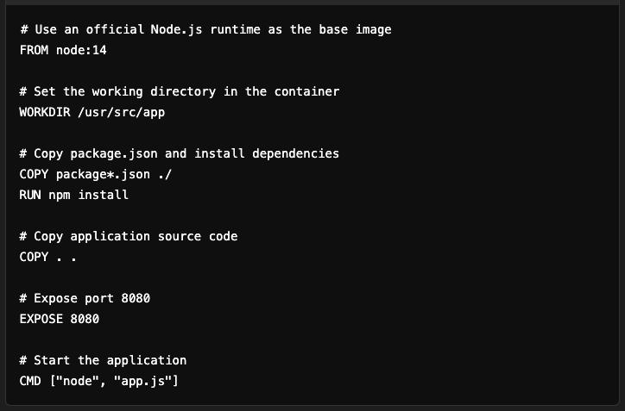

2. Pods (Kubernetes)

2.1 What is a Pod?
A pod is the smallest deployable unit in Kubernetes. It represents a group of one or more containers that:
- Share the same network namespace (can communicate via localhost).
- Share storage volumes if configured.
Pods provide an abstraction layer over containers and are designed to host tightly coupled containers.

2.2 Features of Pods
- Shared Context:
  - Containers in a pod share the same IP address and port space.
  - They can share storage volumes.
- Lifecycle Management: Kubernetes ensures pods are healthy, replacing failed pods automatically.
- Multi-Container Patterns:
  - Sidecar containers: Additional functionality (e.g., logging or monitoring).
  - Ambassador containers: Proxy for communication with external services.

3. Comparison: Containers vs. Pods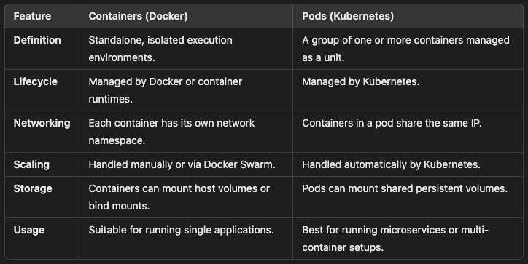

4. How They Work Together

4.1 Docker in Kubernetes
- Kubernetes uses Docker (or other container runtimes like containerd) to run containers inside pods.
- Docker builds and distributes container images that Kubernetes uses to deploy applications.

4.2 Pod Example in Kubernetes
YAML Configuration for a Pod:
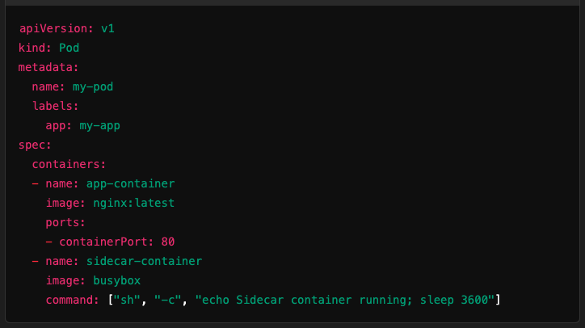
- Main container: Runs nginx.
- Sidecar container: A helper container performing auxiliary tasks.

5. Scaling: Containers vs. Pods

Containers (Docker):
Scaling is typically done manually or using Docker Swarm:

Pods (Kubernetes):
Scaling is automatic using Horizontal Pod Autoscaler (HPA):

6. Benefits of Using Pods in Kubernetes
- Collaboration: Multiple containers working together within a pod.
- Resilience: Kubernetes automatically replaces or restarts pods.
- Scalability: Pods can scale up or down based on demand.
- Observability: Integrated logging and monitoring with tools like Prometheus and Grafana.

7. High-Level Workflow: Docker + Kubernetes
- Build a Docker Image:
  - Create an application and a Dockerfile.
  - Build the image:

  - Push it to a container registry (e.g., Docker Hub, AWS ECR):

- Define Kubernetes Resources:
  - Create a deployment or pod YAML file.
  - Use the Docker image in the pod specification.
- Deploy on Kubernetes:
  - Apply the configuration:

  - Scale and monitor as needed.

8. Summary
- Containers:
  - Lightweight execution units with applications and dependencies.
  - Managed using Docker.
- Pods:
  - Abstraction over containers for managing multiple, related containers.
  - Managed by Kubernetes for deployment, scaling, and orchestration.

By combining Docker and Kubernetes, you can achieve a powerful system for building, deploying, and scaling modern cloud-native applications.

